Michigan EAB project – questions, methods, results
Aaron Tayal
Jan 24, 2025

Introduction

Forest ecosystems are increasingly impacted by anthropogenic stressors, including the establishment and spread of nonnative insects (Lovett et al. 2006). Nonnative woodboring insects have been especially destructive causing significant economic and ecological impacts (ref). High mortality of native tree species often occurs because bottom-up and top-down processes are reduced or absent in the invaded range. Native tree species can lack defenses and be highly vulnerable to nonnative insects because they do not share a coevolutionary history (Villari et al. 2016). Furthermore, when a nonnative insect is introduced to a new region, it often escapes specialist natural enemies which might otherwise control its population (Duan et al. 2023). Release from these bottom-up and top-down factors can result in direct and indirect ecological impacts on native forest ecosystems. Host tree species may be functionally eliminated from forests, or they may persist, potentially in a different size range, or only within a subset of the forest types they once occupied.

Emerald ash borer (EAB, Agrilus planipennis Fairmaire) is an introduced woodboring beetle (Coleoptera: Buprestidae) that has had substantial direct and indirect ecological impacts in forests (Klooster et al. 2018). First identified near Detroit, Michigan in 2002, EAB has since spread throughout the eastern United States and Canada. Extensive mortality of North American ash (Fraxinus spp.) has occurred in regions where EAB has become established, including widely distributed white ash (Fraxinus americana L.), green ash (Fraxinus pennsylvanica Marsh), and black ash (Fraxinus nigra Marsh) (Burns and Honkala 1990, Smith 2006). For example, mixed deciduous forests near the epicenter of the EAB invasion experienced more than 99% mortality of canopy ash by 2009 (Klooster et al. 2014). Concurrent with the death of mature ash, viable seed production, at least in mixed forests, has ceased, causing the germination of new ash seedlings to decline precipitously (Klooster et al. 2014). To control EAB populations, several biological control agents have been released in eastern North America. While populations of these parasitoid wasps have been recovered across the region following release (ref), they have not been effective at preventing ash mortality during EAB outbreaks.

Although the majority of mature ash have died, ash seedlings and saplings that were too small to be colonized by EAB during the initial wave of mortality are abundant in many forest understories (Aubin et al. 2015, Ward et al. 2021). To what extent ash remains a long-term component of forests in eastern North America depends on whether the orphaned cohort of ash can grow large enough to reproduce and generate viable seeds (Aubin et al. 2015). In regions that have experienced the longest duration of EAB impacts such as Michigan and Ohio, populations of EAB have declined due to the reduction in host material but remain at low densities. As ash saplings grow into larger size classes, they become susceptible to EAB, increasing the likelihood that persisting populations of EAB will kill them (Duan et al. 2017). However, recent evidence suggests that the introduced parasitoids could provide enough EAB-population control to protect regenerating ash in post-outbreak forests (Duan et al. 2015, McCullough 2019). Tetrastichus planipennisi Yang (Hymenoptera: Eulophidae) parasitizes EAB larvae through the thinner bark of young ash trees (<12 cm in diameter) (Abell et al. 2012, Duan et al. 2023), while the longer ovipositor of Spathius galinae Belokobylskij (Hymenoptera: Braconidae) may allow it to parasitize EAB larvae within ash trees up to about 39 cm in diameter (Murphy et al. 2017). The long-term persistence of ash populations in natural forests of North America will depend on the dynamic interactions among the orphaned cohort of immature ash in the forest understory, low-density EAB populations, and efficacy of natural enemies.

Because ash previously composed a large portion of total tree biomass in multiple forest types, the death of most overstory ash trees led to a reduction in living tree biomass. It is uncertain which trees, shrubs, or herbaceous plants will replace the space previously occupied by ash trees. In one scenario, the surrounding non-ash canopy trees increase their growth rate after the death of canopy ash, in a process called compensatory growth. Compensatory growth was observed in forests of Ohio between 2012 and 2014, where plots with higher amounts of declining ash trees had higher growth rates of non-ash trees (Hoven et al. 2020). A similar pattern was found using tree cores of red and silver maples (Acer rubrum and Acer saccharinum) in northeast Ohio (Costilow et al. 2017). However, another study which simulated EAB invasion in swamp forests of Upper Michigan found that the growth rates of non-ash overstory trees did not respond to the girdling or cutting of ash trees, at least for the first three growing seasons. Rather, herbaceous plants, including sedges (Carex sp.) and non-graminoid obligate wetland species, increased in the plots where canopy ash were killed (Davis et al. 2017). Similarly, in forests near Toledo, OH, basal area of non-ash trees did not fully compensate for the loss of ash canopy, and the total stand basal area was 8% lower after

What plants will replace the canopy ash trees?
-ash trees themselves
-surrounding canopy trees – but stressors
-tree saplings grow
-graminoids, shrubs, invasive plants

Could ash tree regen occur differently depending on hydrology?

Challenge paragraph:

Given the uncertain future of ash in eastern deciduous forests, it is important to understand the potential for ash survival and regeneration in invaded forests with low-density EAB populations and a history of biological control releases. We resurveyed long-term forest research sites established during the early stages of ash mortality near the epicenter of invasion to investigate the occurrence and health of ash populations more than two decades after the detection of EAB. . Our first objective was to quantify the abundance and health of ash regeneration in hydric, mesic, and xeric forests. Because few reproductively mature ash remain alive in post-outbreak mixed forests (Ward et al. 2021), and the ash seed bank depleted quickly (Klooster et al. 2014), we predicted that newly germinated ash seedlings would be absent. Furthermore, we predicted a higher incidence of signs and symptoms of EAB infestation would be found on trees of larger diameter (Duan et al. 2017). Our second objective was to evaluate whether introduced parasitoid natural enemies of EAB could be recovered at our sites. Our third objective was to determine, within swampy hydric forests, which plant taxa are replacing the space previously occupied by canopy ash trees.

Methods:

Study area
This study was conducted in 37 transects previously established in 2004-2008 in mixed hardwood stands on public land within the Upper Huron River Watershed in southeast Michigan (Table S1) (Smith 2006; Klooster et al. 2014; Smith et al. 2015). Forest stands were originally selected in the Huron-Clinton Metroparks (Indian Springs, Kensington, and Hudson Mills) and Michigan State Recreation Areas (Pontiac, Highland, Proud Lake, and Island Lake) based on the density of ash and their proximity (24-45 km) to the epicenter of EAB invasion in Canton, Michigan (Siegert et al. 2014). Transects were initially characterized by the dominant ash species present (F. americana, F. pennsylvanica, or F. nigra) and edaphic conditions (xeric, mesic, or hydric soils) (Smith 2006; Klooster et al. 2014). Transects in well-drained upland forests with white ash were classified as xeric. Transects with moderately well-drained soils with white and/or green ash were classified as mesic. Transects in floodplains with water-saturated soils, standing water for part of the year, and black ash and/or green ash were classified as hydric. When these transects were first established, ash composed as average of 20-30% of the overstory basal area (Smith 2006). Other common tree genera in these stands included maple (Acer), oak (Quercus), cherry (Prunus), hickory (Carya), tuliptree (Liriodendron), aspen and cottonwood (Populus), elm (Ulmus), basswood (Tilia), hophornbeam (Ostrya), and musclewood (Carpinus) (Smith et al. 2015). Tree species community composition was driven partly by hydrological class, with hydric stands being distinct in composition from mesic and xeric stands (Smith 2006).

Transects consisted of three replicate 18 m radius circular plots (0.1 ha) with a multiscale sampling design to facilitate vegetation surveys (Fig. 1). Each plot is composed of an 18 m radius main plot , one nested 8 m radius subplot, and four 4 m² microplots, one in each cardinal direction. When these transects were established, all plots contained at least two ash (> 10 cm diameter at breast height, DBH). Additional details on plot establishment and characterization are provided in Smith 2006. In the main plot, subplot, and microplots, we resurveyed ash trees, small trees and saplings, and seedlings, respectively, during the growing seasons in 2024 and 2025.
A
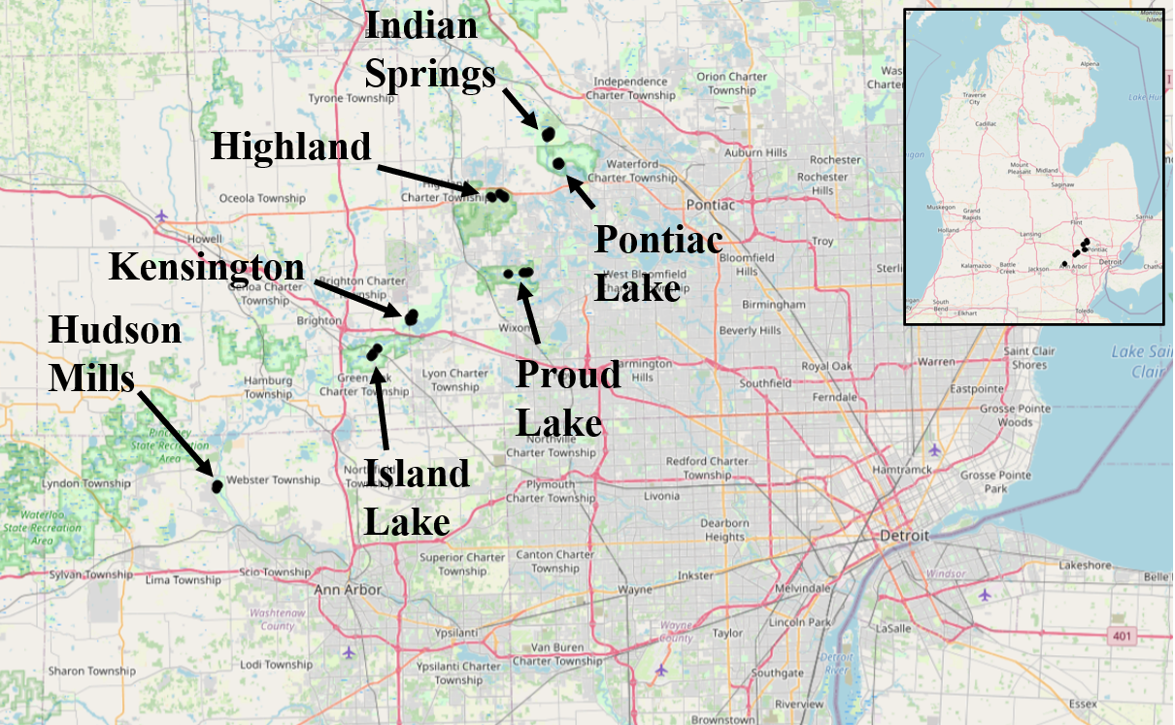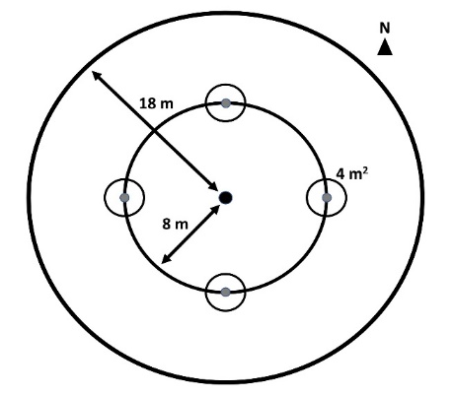
B
Figure 0. A) Map of southeast Michigan, showing the locations of the seven parks where forest stands were surveyed. B) Plot design, showing the 18 m radius main plot, the 8 m radius nested subplot, and the four 4 m² area microplots located in cardinal directions.

Ash abundance and health
To assess the abundance and health of ash, we surveyed overstory ash trees (≥10 cm DBH) within the 18 m radius main plots, understory ash trees (2.5-10 cm DBH) and living ash saplings (≥137 cm in height but <2.5 cm DBH) within the central 8 m radius subplots, and ash seedlings (<137 cm in height) within the 4 m² microplots. While counting ash seedlings, we noted whether any seedlings had cotyledons which would indicate they were newly germinated (Klooster et al. 2014). We counted seedlings in two height categories, <25 cm and >25 cm, and estimated the percentage cover of total ash seedlings in microplots (Klooster et al. 2014).

When present, overstory and understory ash (>2.5 cm DBH) were assessed individually for DBH, species, and health. All DBH measurements were taken at a height of 137 cm (Ward et al. 2021). Due to difficulties in distinguishing green and white ash, species designations were grouped into three categories: 1) black ash; 2) all other species of ash, including white ash, green ash, and potentially pumpkin ash; and 3) unknown ash species because the tree was dead. After recording ash species, we assessed the tree for signs and symptoms of EAB, including the presence of D-shaped emergence holes, woodpecker predation marks, bark splitting, epicormic sprouts, and basal sprouts. Furthermore, we rated the canopy condition using a 1 to 5 scale, where 1 represented a healthy canopy, 5 represented complete defoliation of the canopy, and 2-4 represented increasing stages of decline (Smith 2006, Klooster et al. 2014, Knight et al. 2014). For statistical analyses, we simplified the canopy condition variable into two binary variables, ash tree decline and ash tree death. Ash tree decline was coded as 1 if the canopy condition showed any signs of decline (i.e. if canopy condition ≥ 2) and 0 if the canopy condition = 1. Ash tree death was coded as 1 if canopy condition = 5, and 0 otherwise.

EAB trapping
We used purple-prism traps and multi-funnel traps to assess EAB presence at six of the seven study parks (Supplementary Information, Table S2).

Parasitoid sampling
We used yellow pan trapping to determine whether EAB’s introduced biological control agents were present at one of the parks, Pontiac Lake (Supplementary Information, Table S3, Figure S3).

Statistical analysis
Plot-level densities of ash canopy and understory trees, seedlings, and saplings were calculated by dividing the number of stems by the area over which they were counted. All metrics of ash abundance are reported at the transect level. For ash canopy and understory trees, density of standing dead ash trees (canopy condition = 5) were calculated separately from density of living ash trees (canopy condition < 5). Basal area was calculated for living canopy and understory ash for each tree individually using the formula Σ(π*(d/2)²), where d is the DBH of a tree. Then, the areas of all understory trees were summed and then divided by the subplot area, and the areas of all canopy trees were summed and then divided by the plot area. Basal area was reported in units of m²/hectare. Due to a low number of observations, the density and basal area of canopy ash (> 10 cm DBH) were not tested statistically.

We used the existing categorization of transects (n=30) by hydrological class (xeric (18 transects), mesic (7 transects), and hydric (5 transects), Table S1) to test whether the abundance of ash differs based on soil moisture level. Our response variables were number of short ash seedlings (count), number of tall ash seedlings (count), mean percentage cover of ash seedlings (continuous), number of ash saplings (count), and number of living understory ash trees (count). We created separate models for each response variable. Hydrological class (xeric, mesic, or hydric) was treated as the fixed effect and Park where transect was located as random intercepts to account for unique site conditions at each of the seven parks. For each response variable which is count data, we first tried a Poisson generalized linear mixed-effects model (GLMM) with a log link function, implemented using the package ‘lme4’ in R (Bates et al. 2015). We used the package ‘DHARMa’ to determine if the observed data was adequately modelled by the GLMM (Hartig 2024). Whenever the Poisson GLMM was determined to be overdispersed, we created a new model using the negative binomial error structure. This was implemented using the ‘lme4’ and ‘MASS’ packages in R (Venables et al. 2002). We similarly observed the residuals of the negative binomial GLMM to verify model fit. We compared the Akaike Information Criterion (AIC) between the Poisson and negative binomial models to verify an improvement in fit. The models for number of saplings and number of understory trees were a singular fit or did not converge, so we dropped the random effect of Park for these response variables. The Anova function in the R package “car” (Fox and Weisberg 2019) was used to test for differences in the response variables among hydrological classes, and Tukey contrasts were calculated using the R package ‘emmeans’ (Lenth 2024).

To assess differences in the percentage cover of ash seedlings along hydrological classes, the mean percentage cover of ash seedlings was calculated by averaging values across the 12 microplots in a transect (i.e., four microplots per plot * three plots). Due to issues with homoscedasticity of residuals, we transformed the response variable using the formula y’ = ln(y + 1), where y is the mean percentage cover. We developed a linear mixed-effects model using the R package ‘lme4’ with the transformed mean percentage cover of ash seedlings as the response variable, hydrological class (xeric, mesic, or hydric) as the fixed effect predictor, and Park as random intercepts. The Anova function in the R package ‘car’ was used to test for differences in the percentage cover of ash seedlings among hydrological classes, and Tukey contrasts were calculated using the R package ‘emmeans’.

We hypothesized that ash tree diameter would be positively correlated with signs and symptoms of EAB attack. To test this hypothesis, we used generalized linear mixed-effects models with binomial error structure and a logit link function, implemented using the package “lme4”. Each model included a binary response variable such as presence of bark splitting. The fixed effect predictor variable was always tree diameter at breast height (DBH). We included plot as a random intercept to account for non-independence of trees in a plot. We used a Z-test to test the null hypothesis that the slope coefficient was equal to zero. For our analysis, we pooled understory and overstory ash trees, then excluded any tree belonging to a plot where less than 10 trees were found, which gave us a sample size of 274 trees. We further removed two trees which had missing values, bringing our sample size to 272 trees. To assess the accuracy of the models, we created binned categories of tree diameter and calculated the proportion of trees in each bin that showed the sign or symptom. We observed whether our model line passed through the proportions for each bin, which would indicate a good model fit. To verify that our results did not depend on the data sub-setting criterion, we re-ran the models after only excluding trees belonging to plots where less than 5 trees were found. This adjusted criterion added 20 trees to the model, but did not change any of the results (Table S4).

Results:

In our survey of the 97 plots, we found ash (Fraxinus) in all but 5 plots. We found 2886 ash seedlings, 994 ash saplings, 264 living and 49 dead understory ash trees, and 7 living and 2 dead canopy ash trees. Of the ash seedlings, none had cotyledons, and thus no seedlings were newly germinated in 2024. However, in 2024 we did find isolated examples of ash seed production by four trees in the vicinity our study plots. These trees were located at Indian Springs Metropark and Proud Lake Recreation Area. Three out of four were black ash in hydric plots, and the diameter of the three seed-producing black ash trees ranged from 6.57 cm to 11.5 cm.

In our 2024 EAB trapping survey, the 12 prism traps caught a total of 18 EAB adults over the ~2 month trapping period. Most of the EAB individuals captured were from Kensington Metropark, but EAB was detected at all parks which were investigated except for Proud Lake, which caught zero EAB individuals (no traps were placed at Hudson Mills) (Figure S4). Although prism traps did not recover EAB at Proud Lake, EAB exit holes were still found on ash trees at the park. The three multifunnel traps at Pontiac Lake caught a total of 6 EAB adults. Most (5 of 6) captures occurred between June 4 and June 21, 2024, and all captures were female.

Between June 4 and August 8, 2024, the yellow pan traps caught a total of 1537 Hymenoptera, 1074 Diptera, 1163 Hemiptera, 77 Lepidoptera, 277 Coleoptera, and 152 other arthropods. A total of three introduced biological control agents were detected, including Spathius galinae (3 individuals collected), Oobius agrili (2 individuals collected), and Tetrastichus planipennisi (2 individuals collected).

INSERT INFORMATION ABOUT PARASITOID CAPTURES.

Ash seedlings (<137 cm in height):

Ash seedlings were found in stem densities ranging from 0 to 5.4 stems/m², with an average of 2.0 stems/m². Number of short ash seedlings varied by hydrological class (χ²=10.9, 2 df, p=0.004). Hydric transects had lower numbers of short seedlings than mesic (Z=-3.3, p=0.003) and xeric (Z=-2.6, p=0.027) transects, while differences between mesic and xeric transects were not statistically significant (Fig. 1A). Similarly, number of tall ash seedlings differed by hydrological class (χ²=12.7, p=0.002), with hydric transects having lower numbers than either mesic (Z=-3.5, p=0.001) or xeric (Z=-2.7, p=0.019) transects (Fig. 1A). Mean percentage cover of ash seedlings ranged from 0% to 38%, with an average of 12% across all transects. In mesic and xeric transects, the percentage cover of ash seedlings averaged 17% and 12%, respectively, but hydric transects had only 3% ash seedling cover on average. Statistics supported these trends, with percentage cover of ash seedlings varying by hydrological class (χ²=12.4, p=0.002), and hydric transects having significantly lower percent cover of ash seedlings than mesic (t=-3.2, p=0.010) and xeric transects (t=-3.0, p=0.018).

Ash saplings (≥137 cm in height and <2.5 cm DBH):

The density of ash saplings, across the 30 transects, ranged from 0 to 0.539 stems/m² (0-5390 stems/hectare), with an average of 0.050 stems/m² (500 stems/hectare). Any differences in number of saplings based on transect hydrological class were not significant (χ²=0.4, p=0.82) (Fig. 1B).

Ash small trees (2.5-10 cm DBH) and big trees (≥ 10 cm DBH):

A total of 187 understory ash trees were found in the 30 transects. Of these, 149 were living (canopy condition ≠ 5), while 38 were dead and at least partly standing. The density of living understory ash trees ranged from 0 to 1011 stems/hectare, with a mean of 82.3 stems/hectare. The number of living understory ash trees varied by hydrological class (χ²=8.38, p=0.015). Hydric transects had more understory ash trees than xeric transects (Z=2.5, p=0.033) (Fig. 1C).

Ash big trees (≥ 10 cm DBH):

Only 9 trees were found in the 30 transects, of which 7 were living. Living big trees within the plots ranged in diameter from 10.3 cm DBH to 12.4 cm DBH.

Ash basal area:

The basal area of living understory and canopy ash trees (all ash ≥ 2.5 cm DBH and canopy condition ≠ 5) ranged between 0 and 2.61 m²/hectare, with an average of 0.18 m²/hectare.

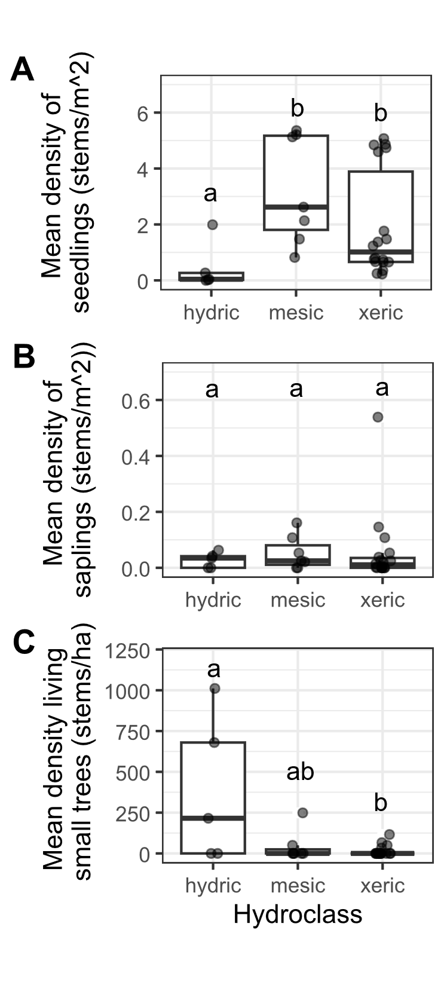
Figure 1. Ash occurrence in 30 transects in the Upper Huron River Watershed in southeast Michigan. The x-axis represents the soil hydroclass of the transect. Data points were overlayed on boxplots, with some horizontal jittering added. Lowercase letters above bars indicate statistically significant differences at α=0.05. A) Mean density of ash seedlings (all ash < 137 cm tall; short and tall seedling categories were combined for the graph), B) mean density of ash saplings (>= 137 cm tall and < 2.5 cm DBH), C) mean density of small ash trees (2.5 cm <= DBH < 10 cm).

Signs and symptoms of EAB

Signs or symptoms of EAB were found on 55 (5.5%) saplings. By far the most common symptom was bark splitting, which was found in 31 subplot quadrants out of 150 subplot quadrants with ash saplings. Other signs and symptoms of EAB were relatively rare or absent on ash saplings, including EAB exit holes (not found on saplings), woodpecker predation marks (found in 1 subplot quadrant), epicormic sprouts (found in 6 subplot quadrants), and basal sprouts (found in 3 subplot quadrants).

Signs and symptoms of EAB on ash trees

The D-shaped emergence holes from EAB were observed on a low percentage of understory and canopy ash, with only 8 ash trees (2%) having exit holes (Fig. S1).

Of the symptoms of EAB, bark splitting was the most common and was found on 179 (56%) ash trees. Epicormic sprouts were found on 116 (36%) ash trees. Basal sprouts and woodpecker predation marks were found on 46 (14%) and 40 (12%) ash trees, respectively.

Out of a total of 320 trees, 220 (69%) had canopy condition=1 (meaning they were healthy), 31 (10%) had canopy condition=2, 12 (4%) had canopy condition=3, 7 (2%) had canopy condition=4, and 50 (16%) had canopy condition=5 (meaning they had a dead canopy).

Relationship between ash tree diameter and EAB symptoms

The presence of woodpecker predation marks was positively correlated with tree diameter (DBH), with a 1 cm increase in DBH increasing the odds of woodpecker marks by 130% (Z=2.96, p=0.003) (Fig. 2A). Similarly, presence of epicormic sprouts was positively correlated with DBH, with a 1 cm increase in DBH increasing the odds of epicormic sprouts by 130% (Z=3.27, p=0.001) (Fig. 2C). The presence of canopy foliage decline was positively correlated with DBH, such that a 1 cm increase in DBH increased the odds of canopy decline by 126% (Z=3.26, p=0.001) (Fig. 2F). The relationship between DBH and bark splitting was not significant (Z=1.75, p=0.080) (Fig. 2B). The relationship between DBH and presence of basal sprouts was not significant (Z=1.75, p=0.080) (Fig. 2D). Additionally, the relationship between DBH and the tree having a canopy condition of 5 (meaning it is dead) was not significant (Z=0.73, p=0.465) (Fig. 2E).

When examining the proportions of trees showing symptoms for groups binned by DBH, we noticed that the 9.5-10.5 cm group and the 10.5-11.5 cm group had lower-than-expected proportions of trees showing symptoms of EAB attack (Fig. 2, red triangles). Thus, the binomial GLMMs are not perfectly modelling the observed patterns. However, it must be noted that many of the ash in the 9.5-11.5 cm DBH range were from only one plot, plot 72 at Indian Springs.

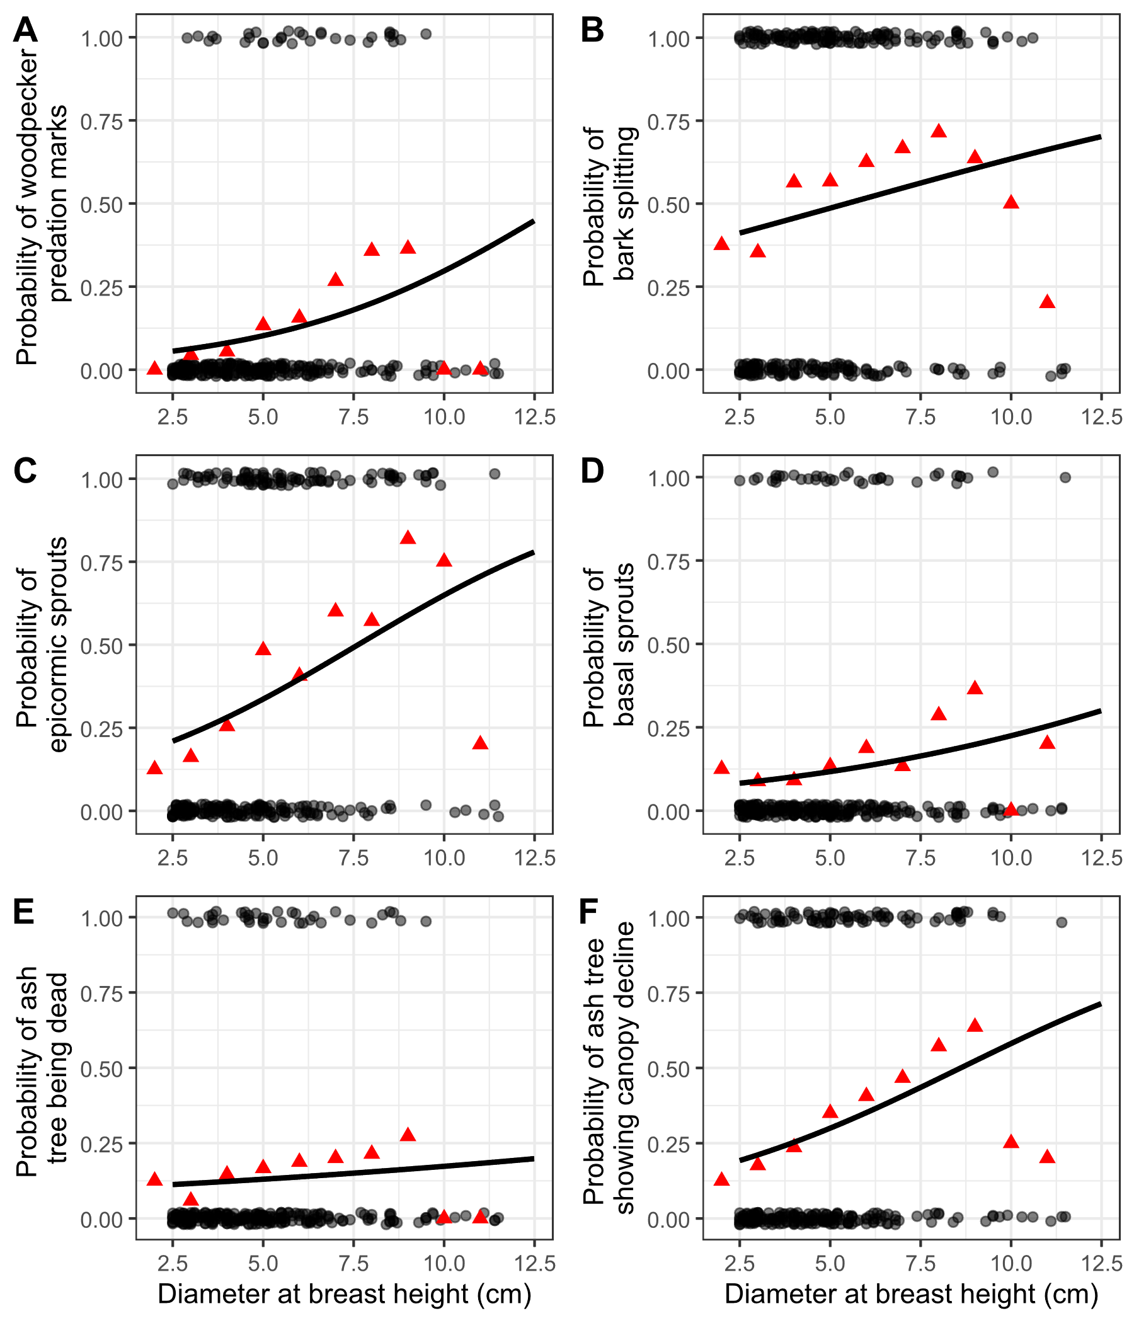
Figure 2. The presence or absence of symptoms of EAB plotted against tree diameter at breast height (DBH) for 272 trees in 9 forest plots. Grey circles are individual trees, which are plotted as y=1 for presence or y=0 for absence (points were jittered slightly up and down). Black line shows the overall fitted model, disregarding each specific random intercept for each plot. Red triangles show the proportion of trees within a DBH bin that have the symptom. For E, tree death is defined as having a canopy condition of 5. For F, canopy decline is defined as having a canopy condition between 2-5 (minor to complete defoliation).

Supplementary Information

EAB Trapping
Two purple-prism traps were installed at each park, for a total of 12 prism traps. Additionally, three multi-funnel (Lindgren) traps were installed at one park, Pontiac Lake Recreation Area. Traps were hung on or near the biggest ash that could be found in preliminary site visits (Supplementary Information). Traps were installed between May 29 and June 5, 2024, and removed between July 23 and July 25, 2024. Purple prism traps used standard purple (“Coroplast purple”) colored board coated with Tangle Trap glue. Traps were hung at varying heights and near ash of varying size classes, depending on what was found at a park (Table S2). All traps were lured with Manuka oil and a fresh lure was installed halfway through the summer between June 25 and July 3. All buprestid beetles were removed from purple prism traps monthly, and from multi-funnel traps weekly, and EAB was identified and sexed (Parsons 2008).

Parasitoid sampling
In 2024, we sampled parasitoid wasps to determine if parasitoids of EAB were present at one of the parks, Pontiac Lake Recreation Area. We chose Plot 53 at Pontiac Lake (Transect: M, Hydroclass: mesic, Plot moisture: 1 (driest)) because initial visits showed large numbers of regenerating ash. Plot 53 is on a hilltop and has a more open canopy in 2024 than other plots at Pontiac. At this plot, bittersweet (Celastrus) vines are commonly growing on the trees.

To evaluate the presence of introduced parasitoids of EAB, we used yellow pan traps. These traps are composed of nested yellow plastic bowls attached to the trunk of a small ash tree and filled with a collection liquid (USDA–APHIS/ARS/FS 2021). We used a modified version of the USDA design, which uses polypropylene webbing straps instead of nails to attach to the tree (Figure S3). On June 4, 2024, 15 traps were attached at a height of 5-6 feet to small green or white ash trees with diameters between 3.2 and 9.6 cm DBH (Table S3). The collection liquid was 20% propylene glycol in water, with 1 drop of unscented dish soap. Traps were collected weekly until August 8, 2024, by pouring the collection liquid through a fine mesh paint filter (listed as 190 micron, actually ~300 micron = 0.3 mm), and rinsing with distilled water. As EAB’s introduced egg parasitoid Oobius agrili is 0.95 mm long (Zhang et al. 2005), a 0.3 mm mesh size should be sufficient to collect most Oobius agrili (although a smaller mesh would be ideal). Paint filters were cooled on ice within 30 minutes and frozen within 1 day (USDA–APHIS/ARS/FS 2021).

To sort trap contents, we placed a paint filter into a petri dish and added 70% isopropanol in distilled water. We discovered that using distilled water for the 70% isopropanol was potentially important for preventing accumulation of mineral debris on small insects. All arthropods, except for thrips, springtails, mites, and small (< 1 mm) larvae, were sorted into broad categories. All Hymenoptera except Symphyta was sorted to superfamily level. Within the Ichneumonoidea, the families Ichneumonidae and Braconidae were distinguished. Within Chalcidoidea, the families Mymaridae and Encyrtidae were distinguished. Furthermore, we searched for the four introduced biological control agents of Agrilus planipennis (EAB), which are Tetrastichus planipennisi (Chalcidoidea: Eulophidae: Tetrastichinae), Spathius galinae and S. agrili (Ichneumonoidea: Braconidae: Doryctinae) and Oobius agrili (Chalcidoidea: Encyrtidae). Parasitoids were identified using the USDA Guidelines (USDA–APHIS/ARS/FS 2021) before being confirmed by expert identification (Toby Petrice, personal communication).

We tested whether the arthropod community differed between ash trees showing canopy decline (indicating possible EAB infection) vs. ash trees with a full canopy. To do this, we categorized the 15 ash trees as either healthy (Canopy condition = 1, 9 trees) or declining (Canopy condition > 1, 6 trees). We used ash tree health (healthy vs. declining) as the predictor variable. Our response variables were the total number individuals of each taxonomic group caught between June 27 and August 1 (these intervals were fully sorted into taxonomic groups). Specifically, we tested any groups for which >= 15 individuals were caught in total, including total number of arthropods, Symphyta (sawflies), Dryinidae (pincer wasps), Formicidae (ants), Pompilloidea (spider wasps), Apoidea (bees and sphecoid wasps), Ichneumonidae, Braconidae, Diapriidae (shelf-faced wasps), Ceraphronoidea, Mymaridae (fairy wasps), Encyrtidae, Platygastroidea, Diptera (flies), Hemiptera (true bugs), Lepidoptera (moths), and Coleoptera (beetles). We ran a Mann-Whitney U-test for each response variable.

Supplementary Tables

Table S1. Plot locations for the 111 plots visited in this study. Each set of three plots makes up a transect. Each transect was given a hydrological class of xeric, mesic, or hydric.

Plot  number | Plot name | Park | Transect | Latitude | Longitude | Hydrological  class
1 | KENUPHD | Kensington | A | 42.53254195 | -83.6705388 | xeric
2 | KENUPHD2 | Kensington | A | 42.53296724 | -83.67076505 | xeric
3 | KENUPHD3 | Kensington | A | 42.53326356 | -83.67093244 | xeric
4 | HMHD | Hudson Mills | AA | 42.37834666 | -83.91336117 | mesic
5 | HMHD2 | Hudson Mills | AA | 42.3779638 | -83.91309216 | mesic
6 | HMHD3 | Hudson Mills | AA | 42.37830402 | -83.91382332 | mesic
7 | KENDRY | Kensington | B | 42.53544514 | -83.66722319 | xeric
8 | KENDRY2 | Kensington | B | 42.53563361 | -83.66642756 | xeric
9 | KENDRY3 | Kensington | B | 42.53588209 | -83.66709668 | xeric
10 | HMDRY | Hudson Mills | BB | 42.37515735 | -83.91411337 | xeric
11 | HMDRY2 | Hudson Mills | BB | 42.37474575 | -83.91429938 | xeric
12 | HMDRY3 | Hudson Mills | BB | 42.37398156 | -83.91421887 | xeric
13 | KENUP | Kensington | C | 42.53463699 | -83.66695495 | xeric
14 | KENUP2 | Kensington | C | 42.53497995 | -83.66657034 | xeric
15 | KENUP3 | Kensington | C | 42.53429542 | -83.66721965 | xeric
16 | ILOPEN | Island Lake | CC | 42.49941418 | -83.7165664 | mesic
17 | ILOPEN2 | Island Lake | CC | 42.50011316 | -83.71690408 | mesic
18 | ILOPEN3 | Island Lake | CC | 42.49984426 | -83.71729405 | mesic
19 | KENDRY3 | Kensington | D | 42.53784433 | -83.66665362 | xeric
20 | KENDRY3A | Kensington | D | 42.53794168 | -83.66596685 | xeric
21 | KENDRY3B | Kensington | D | 42.53727952 | -83.66639485 | xeric
22 | ILLOW | Island Lake | DD | 42.49971912 | -83.71630958 | hydric
23 | ILLOW2 | Island Lake | DD | 42.50085549 | -83.7166848 | hydric
24 | ILLOW3 | Island Lake | DD | 42.49794685 | -83.71775494 | hydric
25 | PLINT | Proud Lake | E | 42.5759159 | -83.52099242 | xeric
26 | PLINT2 | Proud Lake | E | 42.57601569 | -83.52054316 | xeric
27 | PLINT3 | Proud Lake | E | 42.57637225 | -83.52026922 | xeric
28 | HLMAT | Highland | EE | 42.64473456 | -83.56669535 | xeric
29 | HLMAT2 | Highland | EE | 42.64590976 | -83.56680506 | xeric
30 | HLMAT3 | Highland | EE | 42.64686284 | -83.56915982 | xeric
31 | PLDRYMAT | Proud Lake | F | 42.57578816 | -83.52318352 | xeric
32 | PLDRYMAT2 | Proud Lake | F | 42.57577574 | -83.52399007 | xeric
33 | PLDRYMAT2A | Proud Lake | F | 42.57635459 | -83.52182426 | xeric
34 | PLCONF | Proud Lake | G | 42.57571524 | -83.52814029 | xeric
35 | PLDRYMAT3 | Proud Lake | G | 42.57581763 | -83.52740826 | xeric
36 | PLDRYMAT3A | Proud Lake | G | 42.57607392 | -83.52668128 | xeric
37 | PLWET | Proud Lake | H | 42.5747667 | -83.54598723 | hydric
38 | PLWET2 | Proud Lake | H | 42.57474279 | -83.54632682 | hydric
39 | PLWET3 | Proud Lake | H | 42.57428658 | -83.54708265 | hydric
40 | KENWET | Kensington | I | 42.53043348 | -83.67041583 | hydric
41 | KENWET2 | Kensington | I | 42.53110591 | -83.66746124 | hydric
42 | KENWET4 | Kensington | I | 42.53118814 | -83.66648081 | hydric
43 | KENWET3 | Kensington | J | 42.53124676 | -83.66897599 | hydric
44 | KENWET3A | Kensington | J | 42.53101609 | -83.66944111 | hydric
45 | KENWET3B | Kensington | J | 42.53146534 | -83.6685188 | hydric
49 | PONUP | Pontiac Lake | L | 42.67601991 | -83.48374379 | xeric
50 | PONUP2 | Pontiac Lake | L | 42.67639534 | -83.48336561 | xeric
51 | PONUP3 | Pontiac Lake | L | 42.67695181 | -83.48354417 | xeric
52 | PONHD | Pontiac Lake | M | 42.67737591 | -83.4842027 | mesic
53 | PONHD2 | Pontiac Lake | M | 42.67763539 | -83.48494077 | mesic
54 | PONHD3 | Pontiac Lake | M | 42.67619344 | -83.48458083 | mesic
55 | PONEAST | Pontiac Lake | N | 42.67628637 | -83.48161802 | xeric
56 | PONEAST2 | Pontiac Lake | N | 42.67644003 | -83.48223133 | xeric
57 | PONEAST3 | Pontiac Lake | N | 42.67655527 | -83.4827693 | xeric
58 | PONRT | Pontiac Lake | O | 42.67697644 | -83.48225793 | xeric
59 | PONRT2 | Pontiac Lake | O | 42.67847161 | -83.4821571 | xeric
60 | PONRT3 | Pontiac Lake | O | 42.67796779 | -83.48337831 | xeric
61 | ILRIP | Island Lake | P | 42.50511387 | -83.711563 | hydric
62 | ILRIP2 | Island Lake | P | 42.50548015 | -83.71130397 | hydric
63 | ILRIP3 | Island Lake | P | 42.50506543 | -83.71105671 | hydric
64 | ILCC | Island Lake | Q | 42.49871458 | -83.71880034 | hydric
65 | ILCC2 | Island Lake | Q | 42.49826164 | -83.71911588 | hydric
66 | ILCC3 | Island Lake | Q | 42.49755544 | -83.7194028 | hydric
67 | ISMATDRY | Indian Springs | R | 42.70259786 | -83.49652337 | mesic
68 | ISMATDRY2 | Indian Springs | R | 42.70213825 | -83.49648848 | mesic
69 | ISMATDRY3 | Indian Springs | R | 42.70223513 | -83.49584728 | mesic
70 | ISLD | Indian Springs | S | 42.7016922 | -83.49741597 | hydric
71 | ISLD2 | Indian Springs | S | 42.70129243 | -83.49740698 | hydric
72 | ISLD3 | Indian Springs | S | 42.70142849 | -83.49779967 | hydric
73 | ISMATDE | Indian Springs | T | 42.7035437 | -83.49463936 | xeric
74 | ISMATDE2 | Indian Springs | T | 42.70375308 | -83.49415138 | xeric
75 | ISMATDE3 | Indian Springs | T | 42.70278921 | -83.49360562 | xeric
76 | ISRIP | Indian Springs | U | 42.70463303 | -83.49570897 | hydric
77 | ISRIP2 | Indian Springs | U | 42.70481219 | -83.494821 | hydric
78 | ISRIP3 | Indian Springs | U | 42.70487822 | -83.4940807 | hydric
79 | ISOPEN | Indian Springs | V | 42.70480262 | -83.49706373 | mesic
80 | ISOPEN2 | Indian Springs | V | 42.70388702 | -83.49893342 | mesic
81 | ISOPEN3 | Indian Springs | V | 42.7045196 | -83.49803841 | mesic
82 | HLMATFR | Highland | W | 42.6489291 | -83.55636056 | xeric
83 | HLMATFR2 | Highland | W | 42.64858561 | -83.55689617 | xeric
84 | HLMATFR3 | Highland | W | 42.64939898 | -83.55761483 | xeric
85 | HLRIP | Highland | X | 42.64587606 | -83.55093888 | mesic
86 | HLRIP2 | Highland | X | 42.64514371 | -83.55089568 | mesic
87 | HLRIP3 | Highland | X | 42.64637211 | -83.55062169 | mesic
88 | HLUP | Highland | Y | 42.6470476 | -83.55230573 | xeric
89 | HLUP2 | Highland | Y | 42.64705538 | -83.55397741 | xeric
90 | HLUP3 | Highland | Y | 42.6474566 | -83.55365762 | xeric
91 | HMMAT | Hudson Mills | Z | 42.37824499 | -83.91166168 | xeric
92 | HMMAT2 | Hudson Mills | Z | 42.37825474 | -83.91229145 | xeric
93 | HMMAT3 | Hudson Mills | Z | 42.3787298 | -83.91267589 | xeric
94 | PONNEW | Pontiac Lake | ZA | 42.67554541 | -83.48274071 | xeric
95 | PONNEW2 | Pontiac Lake | ZA | 42.67584028 | -83.4830424 | xeric
96 | PONNEW3 | Pontiac Lake | ZA | 42.67606664 | -83.48271281 | xeric
97 | PONRD | Pontiac Lake | ZB | 42.67546355 | -83.4821069 | mesic
98 | PONRD2 | Pontiac Lake | ZB | 42.67597751 | -83.48183457 | mesic
99 | PONRD3 | Pontiac Lake | ZB | 42.67611495 | -83.4822095 | mesic
100 | PONWH | Pontiac Lake | ZC | 42.67657235 | -83.48190157 | xeric
101 | PONWH2 | Pontiac Lake | ZC | 42.67696268 | -83.48095924 | xeric
102 | PONWH3 | Pontiac Lake | ZC | 42.67670871 | -83.48046038 | xeric
103 | ISBR | Indian Springs | ZD | 42.70640403 | -83.49342124 | hydric
104 | ISBR2 | Indian Springs | ZD | 42.70623663 | -83.4938222 | hydric
105 | ISBR3 | Indian Springs | ZD | 42.70670773 | -83.49360969 | hydric
106 | ISBRS | Indian Springs | ZE | 42.70572744 | -83.49386673 | hydric
107 | ISBRS2 | Indian Springs | ZE | 42.70535737 | -83.49412394 | hydric
108 | ISBRS3 | Indian Springs | ZE | 42.70514295 | -83.49498565 | hydric
109 | ISWH | Indian Springs | ZF | 42.70282112 | -83.49624363 | mesic
110 | ISWH2 | Indian Springs | ZF | 42.70256049 | -83.49579452 | mesic
111 | ISWH3 | Indian Springs | ZF | 42.70249606 | -83.49513887 | mesic
112 | KENNEW | Kensington | ZG | 42.53359794 | -83.67122473 | xeric
113 | KENNEW2 | Kensington | ZG | 42.53386003 | -83.67146597 | xeric
114 | KENNEW3 | Kensington | ZG | 42.5343776 | -83.6712658 | xeric

Table S2. Trap locations for the 2024 purple-prism and multi-funnel traps installed to assess EAB presence.

Table S3. Yellow pan trap information for 2024 parasitoid sampling effort. All traps were within ~30 meters of the center tree for Plot 53 at Pontiac Lake Recreation Area.
Trap number | DBH of ash (cm) | Canopy condition  (1-5) | EAB exit holes? | Woodpecker marks? | Ash bark splitting? | Epicormic sprouts? | Basal sprouts? | Canopy condition (binary)
101 | 3.2 | 3 | n | n | y | y | y | Declining
102 | 5.2 | 1 | n | n | y | n | n | Healthy
103 | 6.6 | 1 | n | n | y | y | n | Healthy
104 | 7.2 | 1 | n | n | y | y | n | Healthy
105 | 3.1 | 3 | y | n | y | y | y | Declining
106 | 5.9 | 1 | n | n | y | n | n | Healthy
107 | 3.6 | 1 | n | n | n | y | n | Healthy
108 | 4.45 | 1 | n | n | y | n | n | Healthy
109 | 7.2 | 1 | n | n | y | y | n | Healthy
110 | 8.9 | 1 | n | n | n | n | n | Healthy
111 | 4.6 | 4 | n | n | y | y | y | Declining
112 | 6.7 | 3 | n | n | y | y | n | Declining
113 | 9.6 | 2 | n | n | n | n | n | Declining
114 | 4.2 | 1 | n | n | y | y | n | Healthy
115 | 9.1 | 4 | n | y | y | y | y | Declining

Table S4. Statistical results for the model of the relationship between ash tree diameter and symptoms of EAB. The slope coefficient is the fitted coefficient which is multiplied by tree diameter within the model. The 10-tree criterion is where ash trees were only included if they belonged to plots where 10 or more ash trees were found. The p-value is the probability, under the assumption that the true slope is zero, that we would find a slope coefficient larger in absolute value than the observed slope coefficient. Rows are bolded if the p-value was found to be less than 0.05.
EAB Symptom | Slope coefficient for 10 tree criterion | Slope coefficient for  5 tree criterion | Z value for 10 tree criterion | Z value for 5 tree criterion | p value for 10 tree criterion | p value for 5 tree criterion
Woodpecker marks | 0.26223 | 0.22817 | 2.956 | 2.721 | 0.00312 | 0.0065
Bark splitting | 0.12159 | 0.10369 | 1.752 | 1.474 | 0.0798 | 0.140
Epicormic sprouts | 0.25899 | 0.24421 | 3.273 | 3.179 | 0.00106 | 0.001479
Basal sprouts | 0.1564 | 0.13092 | 1.751 | 1.568 | 0.08 | 0.117
Ash tree death | 0.06692 | 0.04342 | 0.731 | 0.506 | 0.465 | 0.613
Ash tree decline | 0.23492 | 0.18551 | 3.259 | 2.689 | 0.00112 | 0.00717

Supplementary figures

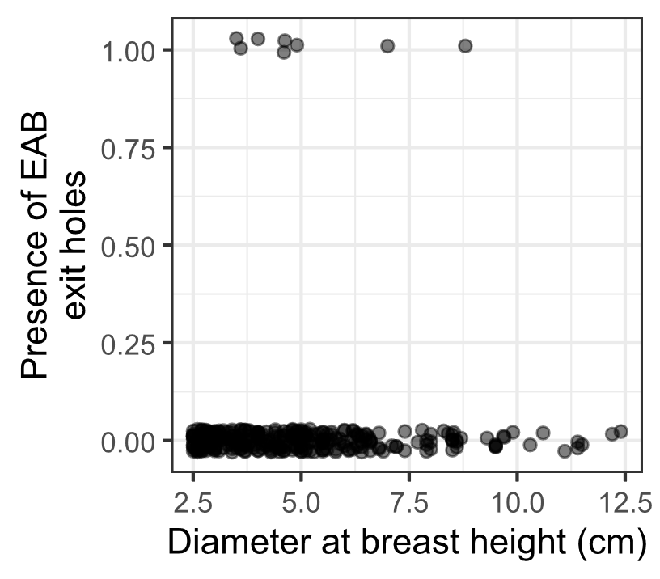
Figure S1. The presence or absence of visible EAB exit holes on the trunk at around eye level. Only 8 of 321 ash trees had EAB exit holes that were spotted. Points are jittered to improve visibility.

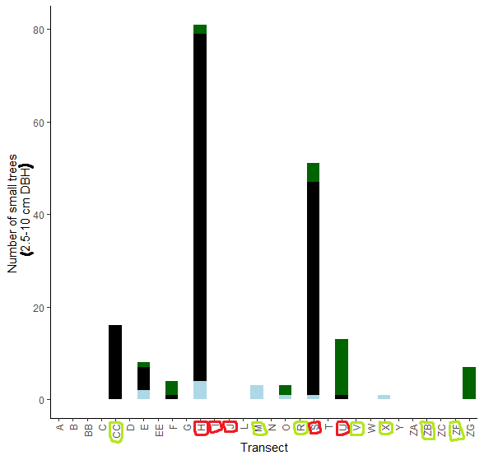
Figure S2. The total number of small ash trees (2.5 – 10 cm DBH) found in 30 completed transects in the Upper Huron River Watershed. Small ash of all canopy conditions are counted. Hydric transects are circled in red, while mesic transects are circled in light green. Bars are shaded based on the proportion of each ash species that was found in a transect. Dark green represents green, white, and/or pumpkin ash; black represents black ash; light blue represents unknown species.

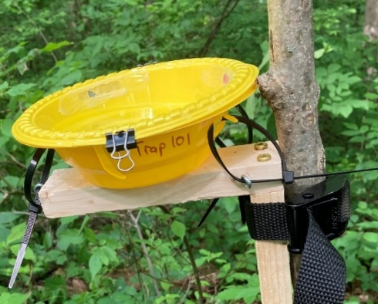
Figure S3. Yellow pan trap design using nested yellow bowls attached to a wooden stand and strapped to an ash tree.

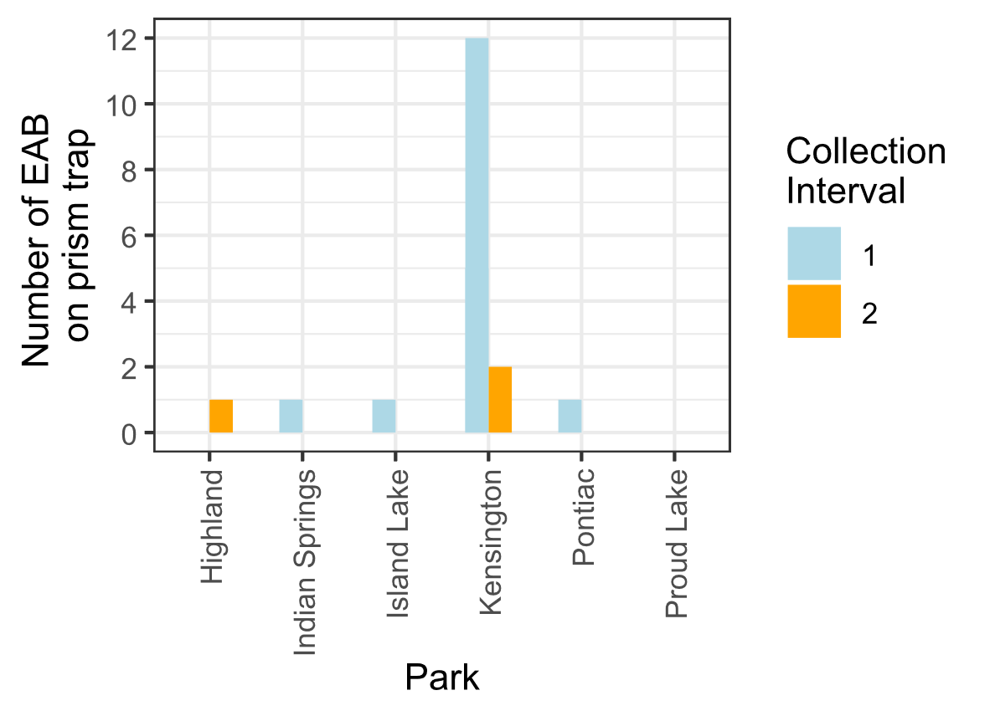
Figure S4. Captures of EAB adults from Prism traps in 2024. Collection interval 1 corresponds to June, while collection interval 2 corresponds to July.

References:

Abell, K. J., L. S. Bauer, J. J. Duan, and R. Van Driesche. 2014. Long-term monitoring of the introduced emerald ash borer (Coleoptera: Buprestidae) egg parasitoid, Oobius agrili (Hymenoptera: Encyrtidae), in Michigan, USA and evaluation of a newly developed monitoring technique. Biological Control 79:36–42.
Abell, K. J., J. J. Duan, L. Bauer, J. P. Lelito, and R. G. Van Driesche. 2012. The effect of bark thickness on host partitioning between Tetrastichus planipennisi (Hymen: Eulophidae) and Atanycolus spp. (Hymen: Braconidae), two parasitoids of emerald ash borer (Coleop: Buprestidae). Biological Control 63:320–325.
Aker, S. A., R. B. De Andrade, J. J. Duan, and D. S. Gruner. 2022. Rapid Spread of an Introduced Parasitoid for Biological Control of Emerald Ash Borer (Coleoptera: Buprestidae) in Maryland. Journal of Economic Entomology 115:381–386.
Aubin, I., F. Cardou, K. Ryall, D. Kreutzweiser, and T. Scarr. 2015. Ash regeneration capacity after emerald ash borer (EAB) outbreaks: Some early results. The Forestry Chronicle 91:291–298.
Barnes, B. V. 1976. Succession in deciduous swamp communities of southeastern Michigan formerly dominated by American elm. Canadian Journal of Botany 54:19–24.
Bates, D., M. Mächler, B. Bolker, and S. Walker. 2015. Fitting Linear Mixed-Effects Models Using lme4. Journal of Statistical Software 67.
Burns, R., and B. Honkala. 1990. Silvics of North America: Volume 2, Hardwoods.
Costilow, K. C., K. S. Knight, and C. E. Flower. 2017. Disturbance severity and canopy position control the radial growth response of maple trees (Acer spp.) in forests of northwest Ohio impacted by emerald ash borer (Agrilus planipennis). Annals of Forest Science 74:10.
Davis, J. C., J. P. Shannon, N. W. Bolton, R. K. Kolka, and T. G. Pypker. 2017. Vegetation responses to simulated emerald ash borer infestation in Fraxinus nigra dominated wetlands of Upper Michigan, USA. Canadian Journal of Forest Research 47:319–330.
Duan, J. J., L. S. Bauer, K. J. Abell, M. D. Ulyshen, and R. G. Van Driesche. 2015. Population dynamics of an invasive forest insect and associated natural enemies in the aftermath of invasion: implications for biological control. Journal of Applied Ecology 52:1246–1254.
Duan, J. J., L. S. Bauer, and R. G. Van Driesche. 2017. Emerald ash borer biocontrol in ash saplings: The potential for early stage recovery of North American ash trees. Forest Ecology and Management 394:64–72.
Duan, J. J., J. R. Gould, N. F. Quinn, T. R. Petrice, B. H. Slager, T. M. Poland, L. S. Bauer, C. E. Rutledge, J. S. Elkinton, and R. G. Van Driesche. 2023. Protection of North American ash against emerald ash borer with biological control: ecological premises and progress toward success. BioControl 68:87–100.
Fox, J., and S. Weisberg. 2019. An {R} Companion to Applied Regression. Sage, Thousand Oaks {CA}.
Hartig, F. 2024. DHARMa: Residual Diagnostics for Hierarchical (Multi-Level / Mixed) Regression Models. R.
Hoven, B. M., K. S. Knight, V. E. Peters, and D. L. Gorchov. 2020. Release and suppression: forest layer responses to emerald ash borer (Agrilus planipennis)-caused ash death. Annals of Forest Science 77:10.
Jones, M. I., J. R. Gould, H. J. Mahon, and M. K. Fierke. 2020. Phenology of Emerald Ash Borer (Coleoptera: Buprestidae) and Its Introduced Larval Parasitoids in the Northeastern United States. Journal of Economic Entomology 113:622–632.
Klooster, W., K. Gandhi, L. Long, K. Perry, K. Rice, and D. Herms. 2018. Ecological Impacts of Emerald Ash Borer in Forests at the Epicenter of the Invasion in North America. Forests 9:250.
Klooster, W. S., D. A. Herms, K. S. Knight, C. P. Herms, D. G. McCullough, A. Smith, K. J. K. Gandhi, and J. Cardina. 2014. Ash (Fraxinus spp.) mortality, regeneration, and seed bank dynamics in mixed hardwood forests following invasion by emerald ash borer (Agrilus planipennis). Biological Invasions 16:859–873.
Knight, K. S., B. P. Flash, R. H. Kappler, J. A. Throckmorton, B. Grafton, and C. E. Flower. 2014. Monitoring Ash (Fraxinus spp.) Decline and Emerald Ash Borer (Agrilus planipennis) Symptoms in Infested Areas. General Technical Report, U.S. Department of Agriculture, Forest Service, Northern Research Station.
Lenth, R. V. 2024. emmeans: Estimated Marginal Means, aka Least-Squares Means. R.
Lovett, G. M., C. D. Canham, M. A. Arthur, K. C. Weathers, and R. D. Fitzhugh. 2006. Forest Ecosystem Responses to Exotic Pests and Pathogens in Eastern North America. BioScience 56:395.
Marshall, J. M., E. L. Smith, R. Mech, and A. J. Storer. 2013. Estimates of Agrilus planipennis Infestation Rates and Potential Survival of Ash. American Midland Naturalist 169:179–193.
McCormick, J. F., and R. B. Platt. 1980. Recovery of an Appalachian Forest Following the Chestnut Blight or Catherine Keever-You Were Right! American Midland Naturalist 104:264.
McCullough, D. G. 2019. Challenges, tactics and integrated management of emerald ash borer in North America. Forestry: An International Journal of Forest Research 93:197–211.
Morin, R. S., and A. M. Liebhold. 2015. Invasions by two non-native insects alter regional forest species composition and successional trajectories. Forest Ecology and Management 341:67–74.
Murphy, T. C., R. G. Van Driesche, J. R. Gould, and J. S. Elkinton. 2017. Can Spathius galinae attack emerald ash borer larvae feeding in large ash trees? Biological Control 114:8–13.
Parsons, G. 2008. Emerald Ash Borer: A guide to identification and comparison to similar species. Michigan State University Department of Entomology.
Perry, K., D. Herms, W. Klooster, A. Smith, D. Hartzler, D. Coyle, and K. Gandhi. 2018. Downed Coarse Woody Debris Dynamics in Ash (Fraxinus spp.) Stands Invaded by Emerald Ash Borer (Agrilus planipennis Fairmaire). Forests 9:191.
Slesak, R. A., C. F. Lenhart, K. N. Brooks, A. W. D’Amato, and B. J. Palik. 2014. Water table response to harvesting and simulated emerald ash borer mortality in black ash wetlands in Minnesota, USA. Canadian Journal of Forest Research 44:961–968.
Smith, A. 2006. Effects of Community Structure on Forest susceptibility and Response to the Emerald Ash Borer Invasion of the Huron River Watershed in Southeast Michigan. Master’s Thesis, The Ohio State University.
Stadler, B., T. Müller, and D. Orwig. 2006. THE ECOLOGY OF ENERGY AND NUTRIENT FLUXES IN HEMLOCK FORESTS INVADED BY HEMLOCK WOOLLY ADELGID. Ecology 87:1792–1804.
Timms, L. L., S. M. Smith, and P. De Groot. 2006. Patterns in the within‐tree distribution of the emerald ash borer Agrilus planipennis (Fairmaire) in young, green‐ash plantations of south‐western Ontario, Canada. Agricultural and Forest Entomology 8:313–321.
USDA–APHIS/ARS/FS. 2021. Emerald Ash Borer Biological Control Release and Recovery Guidelines. USDA–APHIS–ARS–FS, Riverdale, Maryland.
Van Grinsven, M., J. Shannon, N. Bolton, J. Davis, N. J. Noh, J. Wagenbrenner, R. Kolka, and T. Pypker. 2018. Response of Black Ash Wetland Gaseous Soil Carbon Fluxes to a Simulated Emerald Ash Borer Infestation. Forests 9:324.
Venables, W. N., B. D. Ripley, and W. N. Venables. 2002. Modern applied statistics with S. 4th ed. Springer, New York.
Villari, C., D. A. Herms, J. G. A. Whitehill, D. Cipollini, and P. Bonello. 2016. Progress and gaps in understanding mechanisms of ash tree resistance to emerald ash borer, a model for wood‐boring insects that kill angiosperms. New Phytologist 209:63–79.
Wagner, D. L., and K. J. Todd. 2016. New Ecological Assessment for the Emerald Ash Borer: A Cautionary Tale About Unvetted Host-Plant Literature. American Entomologist 62:26–35.
Ward, S. F., A. M. Liebhold, R. S. Morin, and S. Fei. 2021. Population dynamics of ash across the eastern USA following invasion by emerald ash borer. Forest Ecology and Management 479:1–8.
Zhang, Y.-Z., D.-W. Huang, T.-H. Zho, H.-P. Liu, and L. S. Bauer. 2005. Two new species of egg parasitoids (hymenoptera: Encyrtidae) of wood-boring beetle pests from China. Phytoparasitica 33:253–260.

